**52. Spring Security - User Roles**

**Display User ID and Roles**:

Here we will display the user id and roles in our Home page.

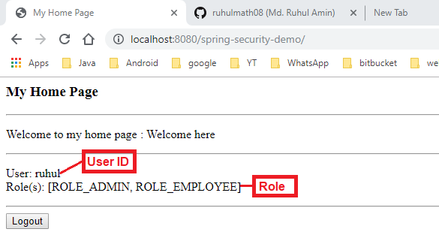

**Spring Security**:

* Spring Security provides JSP custom tags for accessing user id and roles

**Development Process**:

1. Update POM file for Spring Security JSP Tag Library
2. Add Spring Security JSP Tag Library to JSP page
3. Display User ID
4. Display User Roles

**Step 1: Update POM file for Spring Security JSP Tag Library**:

<!-- Add Spring Security Taglibs Support -->

<dependency>

<groupId>org.springframework.security</groupId>

<artifactId>spring-security-taglibs</artifactId>

<version>${springsecurity.version}</version>

</dependency>

**Step 2: Add Spring Security JSP Tag Library to JSP page**:

<!-- Add Spring Security Taglibs Support in JSP page-->

<%@ taglib prefix=*"security"*

uri=*"http://www.springframework.org/security/tags"*%>

**Step 3: Display User ID**:

<%@ taglib prefix=*"security"*

uri=*"http://www.springframework.org/security/tags"*%>

...

<!-- Display user-name and role -->

<p>

<!-- User ID -->

User: <security:authentication property=*"principal.username"* />

<br />

</p>

**Step 3: Display User Roles**:

<%@ taglib prefix=*"security"*

uri=*"http://www.springframework.org/security/tags"*%>

...

<!-- Display user-name and role -->

<p>

<!-- User Roles -->

Role(s): <security:authentication property=*"principal.authorities"* />

</p>

52. Spring Security - User Roles